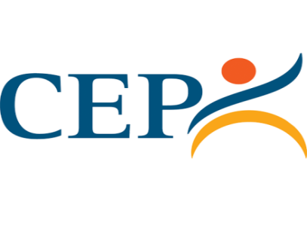
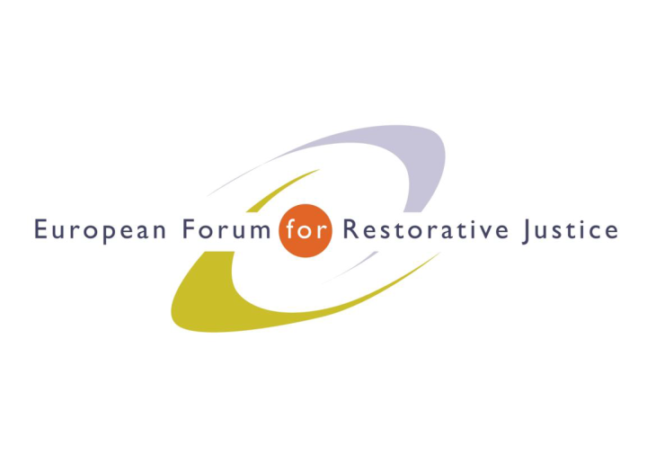
Criminal Justice Platform Europe
Radicalisation and Violent Extremism Conference, Barcelona, 14th October 2015
Criminal Justice Platform/Centre of Legal Studies
Workshop 1
Chair: Willem van der Brugge, Secretary General, CEP
Experts: Ms Eve Entenmann, International Centre for Counter Terrorism, (NL)
Mr Alberto Olalde, School of Social Work, University of Basque Country, (E)
Participants: 20
Notes: John Scott
Impression: Good attendance: participants appreciated the opportunity to engage with the speakers leading to stimulating questions to both of the experts. Positive atmosphere.
---------------------------------------------------------------------------------------------------------------------------------------
Ms Eve Intenmann is ‎Programme Manager of the International Centre for Counter Terrorism in the Netherlands. She added to her plenary presentation by reporting on field work in Africa and the far East. She stressed the following items:
- The importance of focusing on youth
- That victims of terrorism represent a very difficult field – but that empowerment of victims was crucial for example, victims going into schools near the centres of radicalization. It was a very powerful message to say ‘I lost my father/mother’.
Mr Alberto Olalde from the School of Social Work, University of Basque Country, gave a case illustration of ‘Carlo’ who had been convicted of 12 killings and, while serving his prison sentence, wanted to contribute to reducing harm. He was prepared to meet with his victims’ family members. All 12 were contacted and two families started the process of setting up a meeting – one said s/he ‘needed that to heal the harm’. ‘Carlo’ began discussions and preparation for the meetings via role play, but there was a Government intervention imposing a condition that a Government representative would have to attend to take notes cancelling any prospect of confidentiality for the victim and the offender. The process halted and has not been continued.
The workshop continued via questions from the floor:
- Imposed conditions were the subject of the first question.
- What were the role of Victim Support Associations? In some countries they were adamantly against mediation and sought only revenge and longer sentences. They are often part of the political process and very influential. Programs needed to allow time and energy to engage with relevant victim organisations to avoid creating later obstacles for the work.
- Where does prison fit into the three levels identified by Ms Entenmann? The answer covered the individual level where a meeting with a victim or victim representative could be the shock needed to persuade the offender to re-consider the religious or political extremist position. The environmental level was key to isolation and avoidance of creating a self-perpetuating extremist group within the prison. There was discussion of the implications for a life prisoner who would never be released.
- How to achieve a more effective voice for victims? It was a big challenge to confront extremists with victims – one route was to ensure that the religion and ethnicity of the perpetrator and victim are matched. Another was to meet in schools or Mosques so the environment was non-confrontational – particularly with young people for whom ‘learning’ was the key. A process of ‘forgiveness’ was another focus.
- What was the difference with offenders motivated by a political or separatist programme? There is a need to recognize the human in the conflict – that a peace process might separate the offender from ‘common’ criminals but an alteration in the macro political priorities can set processes back many years – e.g. a more punitive Government. Workers needed to work on the post-conflict scenario as well as the current focus.
- Macro level ‘restorative justice’ process was vital – e.g. the Peace and Reconciliation process in South Africa where clear leadership was essential for moral and practical reasons.
- A problem for probation was to define the community standards for de-radicalisation – to identify what were the similarities and differences in working with – gangs, jihadists or white supremacists for example.
- What were the lessons for prevention? Organised crime was used as an illustration – in Italy, work was concentrated on the 14-18 age group on ‘stop violence programmes’. In Sweden, similar methods were a priority and rehabilitation for released extremist prisoners was compared to Circles of Support and Accountability – methods used to reduce the risk of sex offenders re-offending using volunteers and ex-offenders. There was a cautious note about involving past-radicalised offenders, care needed to ensure that the person has moved on and sustained a resolved set of attitudes and experiences.

Willem van der Brugge thanked the presenters and participants for their contributions to an excellent workshop.
EuroPris - European Organisation of Prison and Correctional Services
EFRJ- European Forum for Restorative Justice
CEP - Confederation of European Probation

