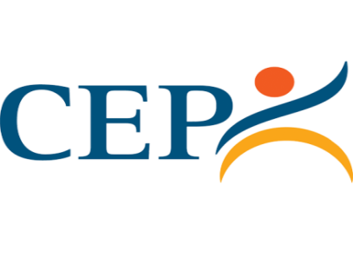
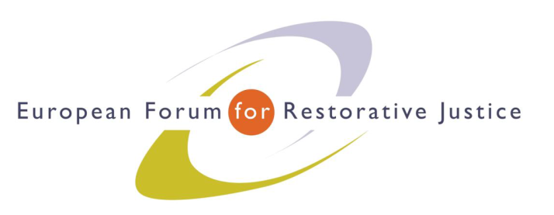
Criminal Justice Platform Europe
Radicalisation and Violent Extremism Conference, Barcelona, 14th October 2015

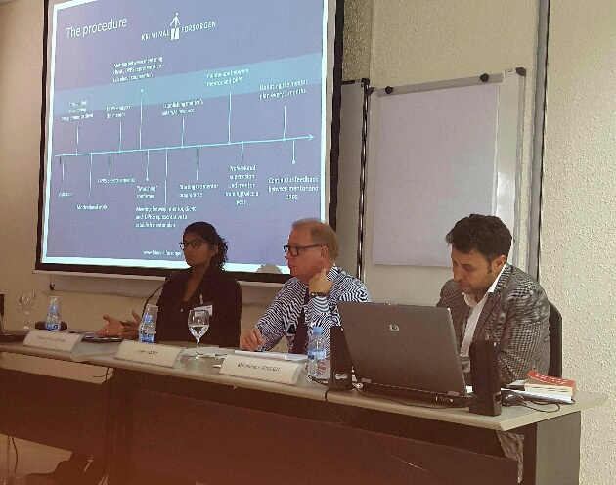
Criminal Justice Platform/Centre of Legal Studies
Workshop 3
Chair: John Scott
Experts: Ms Rekha Grue Larsen (DK),
Mr Mohamed Ajouaou (NL)
Participants: 14
Notes: Willem van der Brugge
Impression: Good atmosphere: lively discussion and interaction, various questions to both of the experts
---------------------------------------------------------------------------------------------------------------------------------------
Ms Rekka Grue Larsen is ‎Programme Officer at the Danish Prison and Probation Service. She explained the proces of the 'Back on Track' programme. She presented the procedure of the programme by showing a process map of the 'mentoring' procedure. Mr Mohamed Ajouaou is the executive manager of the Dutch Imams working in Dutch prisons and penitentiary institutions. He illustrated the diversity of the Dutch Imams by showing a picture of his 'prison team' : male and female imams, representing all Islamic traditions and movements except the extreme beliefs. He illustrated the delicate position of the clergy in prison presenting a case study provided by one of the Dutch imams. The Iman was confronted with a detainee who expressed his radicalized ideas on how to deal with the community once he was released. The imam had to consider how to deal with this 'confidential' information. Case studies like this can be part of inter-colleagial supervision sessions. The workshop continued via questions from the floor:
- Are group sessions part of the programme? The ‘Back on Track’ mentoring procedure is an individual plan; although all steps (e.g. assessment, contacts with the case-manager) of the process maps are the same; intensity and time frames may differ.
- How is the programme positioned in the framework of probation measures? Ms Rekka Grue Larsen explained that the ‘Back on Track’ mentoring plan is always part of a detention or probation (supervision) plan which drives the work; in most cases, a probation officer is the case manager. In principle the mentor reports to the case manager at fixed intervals (every 3 months?).
- How does selection of Back on Track mentors takes place? Ms Rekka Grue Larsen clarified that a standard procedure is used to select the mentors (as used for all volunteers within the prison and probation sector in Denmark).
- What skills are needed to become a ‘Back on Track’ mentor? Ms Rekka Grue Larsen explained that no specific skills are needed to become a mentor. Most important is the 'match' between the service-user and the mentor - gender can be an important issue. Some male service users prefer a female mentor. Sharing the same interest can also be important (e.g. fishing or just having a dog!). The service user has to agree with the choice of the mentor. After all they have to cooperate well during the course of the programme.
- What is the average caseload of a Back on Track mentor? Almost all mentors supervise just one service user; average caseload = 1.1
- How do Imams deal with confidentiality versus safety issues in prison practice? Mr Ajouaou stressed that the clergy are aware of their special position in the correctional system. They know when confidentiality stops and safety and security of other detainees and prison staff takes over.
- What is the view of the Prison Administration on the various religious movements in Islam? Mr Ajouaou stressed that there is no general view on Islam (like in all other religions) within the Correctional Service. It is of the utmost importance that Imams respect the democatric principles and traditions of the Dutch Society.
- How does selection of Imans takes place? The selection procedure is more or less standardised. All Imams have to have a master’s degree in theology; a selection form/assessment tool focuses on special issues. Imams have to meet the selection criteria of the Dutch Correctional Adminstration. All Imams working in the Dutch Correctional Administration are civil servants and are held to basic principles concerning integrety and confidentiality.
- Can individuals choose their own Imam in prison? According to Dutch Prison legislation every detainee has to have access to religious services. In every Dutch correctional Institute an Imam, a priest, a vicar, humanist and counselor is appointed. He or she is a member of the prison staff.
John Scott thanked the presenters and participants for their contributions to an excellent workshop.

EuroPris - European Organisation of Prison and Correctional Services
EFRJ- European Forum for Restorative Justice
CEP - Confederation of European Probation

