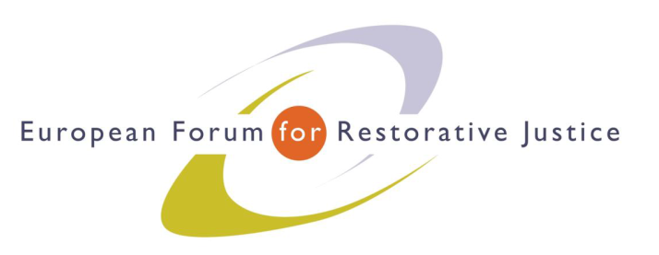
Criminal Justice Platform Europe
Radicalisation and Violent Extremism Conference, Barcelona, 14th October 2015
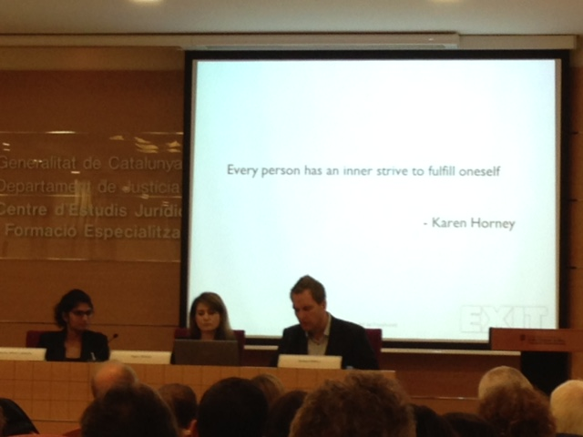
Criminal Justice Platform/Centre of Legal Studies
Workshop 4
Chair: Ms Kirsten Hawlitschek, Executive Director EuroPris
Experts: Ms Marie Louise Jørgensen, Security Advisor from the Back on Track Programme, Prison and Probation Service, Denmark
Mr Robert Örell, Director of the Exit Programme, Sweden
Ms Figen Özsöz, from the Bavarian State Criminal Police Office, Germany
Participants: 56
Notes: Mirko Miceli
Impression: Good attendance; wide range of questions; good participation and interest.
---------------------------------------------------------------------------------------------------------------------------------------
Workshop session Questions
To Figen Özsöz
Q: Is it possible to apply anything specific from these groups to other groups?
A: It is not good to segregate. Better to mix them up in small units reinforcing their ideology. They build subculture. Plus they can act as a group.
Speaker: prison staff they should know more about right-wings extremists. For instance the music the listen they listen to, the symbols. The detainees they see, they are able to convey their affiliation. White-extremists adapt to prison rules rather easily and therefore conflict with the prison staff is rare, so prison staff think they are easy-prisoners. Therefore they can act free of control.
Danish Mentoring Programme:
How we run the case:
Assessing the person and identify a possible mentor.
Prison, or social worker, and the idea of a mentor introduced to the client
Motivational work: they start to convince him to get out of crime path
( personal case: Muslim suggested an intimate for the cartoonist)
Presentation of the mentor to the client: matching and meeting
Presenting the mentor role and how the detainee can benefit from the mentoring programme
Establishing worksheet and allowance of the mentor
Start of the work: presenting a small report on the follow up meetings
Educational 2 days a year for mentors
Updating mentor plan every 3 months
Sweden
After a PhD study findings show:
1) Shared past
2) informal dialogue: settings matter (coffee, gym, doesn’t matter)
3) meaning of the first meeting. It is real important. Due to their background confrontation and power control should not be strong at the very beginning.
After the presentations of a real case (details NOT TO BE DISCOLSED).
Q: How do you assess the success of the programme?
A: We have to ask him if has changed in behaviour and we look at other indicators. We train other staff to spot these signs.
Q: The relationship between practitioner and the client is important based on our study too.
What’s the assessment of the risks and individual needs before you intervene.
A: the relationship is important not the background.
Assessment: we focus a lot on building trust initially and then we assess as we go the needs and risks. It comes along as we work. Some failures are due to the initial assessment. PhD available in English in 1 month.
Q:
Denmark
1 How often they meet the clients? Individual plan. It depends on the case and needs. If in prison some measures to be taken into account
2 programmes after prison? Mentors also before (other alternative measures like social works)
3 Some clients don’ t want mentor we cannot change and we will keep trying to reach the client.

Sweden
1 Case by case and needs (client, resources, time….etc). Phone also a possibility. Preferences of the clients
2 Voluntary nature of the process? Yes, we cannot force anybody to have a meeting
3 post prison: not all of our clients have prison records.
Q. You describe ordinary social work. I wish everyone could benefit from these programmes. You focus on a specific type of offenders with the same methodology? Is there anything specific of your job?
Denmark: We have mentor for all crimes, before prison and on probation .
Sweden: If we look at the methodology it’s based on psychotherapy but you have to know the specific target group. When it comes to violent extremist you need a specific training. This is not new things here. Nothing has been invented but we just use something very specific.
Q: We have been talking about people who already started a de-radicalisation process. How do you work with them? Do you include the community or family?
Swe: timing and motivation goes together. Lot of them during custody or life changing events. Parental support too: but families do not what to do. Raising awareness on the family environment to have a more constructive response.
Den: in two planning an attack cases. They were getting married with women outside. In that moment when we proposed to help would-be wives through the mentor they accepted the process.
Q: What can prison staff do in these cases?
DEN: The dynamic security is crucial to interact with the client. The mentors will work together on the issue.
SW: relationship with prison staff is important. Our work sometimes very difficult is not supported by staff.
Q: Are you a large enough organisation?
SW: Exit is the only one working on this category (white power groups) but other NGOs are active on gang-related cases more in general.
We complement each other (Prison Ministry). Bring change with ordinary programme alone would be difficult.
DEN: In our exit programme in the prison and probation we realised that in last three years a government body has asked us to exit members from gangs. However, it good to have both options: NGOs and government services.
Q: Imam should be included in your programmes?
SW: multi-disciplinary work is also good, but it’s up to client. As a general recommendation yes.
DEN: we have imam. Done in many cases, so it depends on the case.
Q: How is Exit funded?
SW: from the State and also a foundation and another part we sell services to schools.

EuroPris - European Organisation of Prison and Correctional Services
EFRJ- European Forum for Restorative Justice
CEP - Confederation of European Probation

