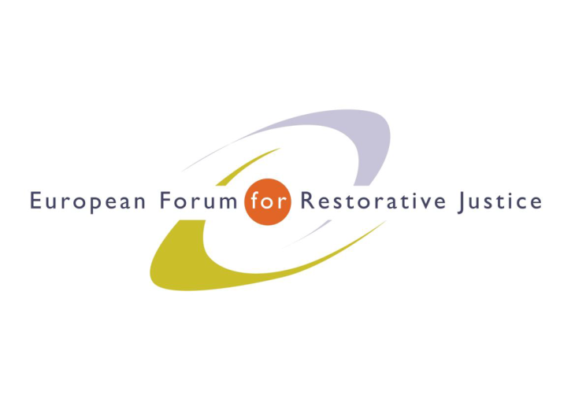
Criminal Justice Platform Europe
Radicalisation and Violent Extremism Conference, Barcelona, 14th October 2015
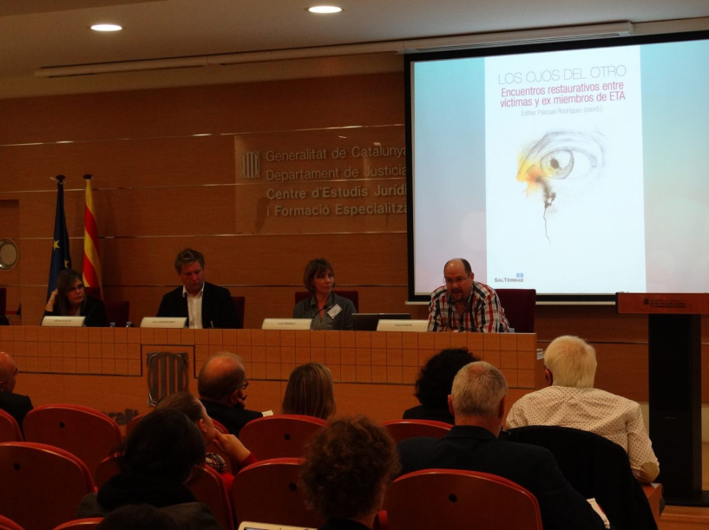
Criminal Justice Platform/Centre of Legal Studies
Plenary session 2
Chair: Mr Kris Vanspauwen. Executive officer EFRJ
Experts: Carys Keane - National Offender Management Service – United Kingdom
Julia Reinelt – Practitioner and Head of international affairs at Violence Prevention Network – Germany
Alberto Olalde – School of Social Work. University of Basque Country – Spain

Participants: 89
Notes: Ricardo Tarantelli
---------------------------------------------------------------------------------------------------------------------------------------
It is a challenge to develop strategies for deradicalisation. In recent years we have been able to develop tools to stop offender from committing violent crimes but it is not easy to stop them in their beliefs. I think it’s important we turn to the rehabilitation and counter radicalisation topic.
Assessment and intervention of extremist offenders Ms Carys Keane - National Offender Management Service – United Kingdom
Psychologist, responsible for the development, implementation and intervention for extremists –
We have been lucky to have almost a decade to develop these kind interventions. Since the UK bombing there has been an ongoing development. However, we don’t know an unique explanations of extremism. In fact, there are different pathways that individual take in order to radicalise. In the UK the intervention is focused on 4 dimensions as we are aware of the fact that radicalisation is a dynamic process: we acknowledge that people may take various stage according the their personality. Identity is the unifying construct as it is the main reason why these individuals commits acts of violence. The individuals disengage step by step likewise their previous engagement: people offend for purposes and needs according to the “good lives model/desistance”. Engagement; identification; intent; capability are the 4 steps that lead a person to commit an act of violence. There are also two pathways into extremisms: non-criminal and criminal. Disengagement is associated with stopping the pursuing of radical and extremist ideas. The assessment is carried out through “extremist risk guidelines” and “extremism risk screening” and it is done by psychologist and by probation officers while the detainee is on probation. We found that mental health plays a big role therefore we have the healthy identity intervention; developing dialogues and other interventions (im) to disengage people with mental disorders from radical views.

Violence Prevention Network (VPN). Ms Julia Reinelt – Practitioner and Head of international affairs at Violence Prevention Network – Germany
The mission statement of the violence prevention network is to disengage people with radical views and to reintegrate them into society. The current projects involve the youth who are undergoing a process of radicalisation (special regards toward foreign fighters), it is also possible for relatives and friends of recruited to call a hotline and aware the institutions of the threat. A dialogue with the radicalised individual is fundamental but only if they accept to talk. The education of responsibility is one of the pillar of the disengagement programme, de radicalisation in prison, participation in deradicalisation programme (step 1) and stabilisation coaching after release (step 2). The de radicalisation programme is enabled in 6 different German prisons and the percentage of recidivism in the VPM programme was 52,1% well below the national average of 75,6% .

Dealing with reintegration of former ETA members in Basque Country. Mr Alberto Olalde – School of Social Work. University of Basque Country – Spain
Prisoners who wanted to contribute to reduce the harm of victims initiated the project. It was important that in 2011 the Spanish and Basque government found out that it was useful to work on this project, although the Spanish government pulled out believing it was not good for them. Importance in promoting retributive justice within the European Union to prepare and support dialogue for victims and offenders, as we believe in interpersonal conversation between the victims and the offenders. This process is emotionally intense and therefore we need a facilitator. Restorative encounters work because they contribute to help the victims to handle their personal way out of the grievance, while the offenders have a good motivation in taking the whole responsibility and to forgive themselves.

EuroPris - European Organisation of Prison and Correctional Services
EFRJ- European Forum for Restorative Justice
CEP - Confederation of European Probation

