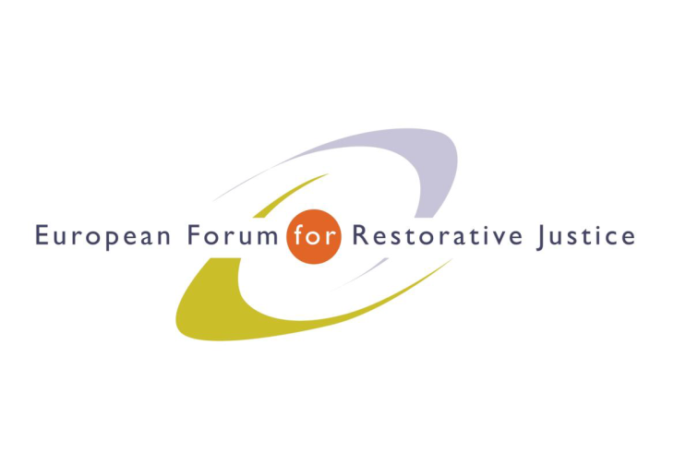
Criminal Justice Platform Europe

Radicalisation and Violent Extremism Conference, Barcelona, 14th October 2015
Criminal Justice Platform/Centre of Legal Studies
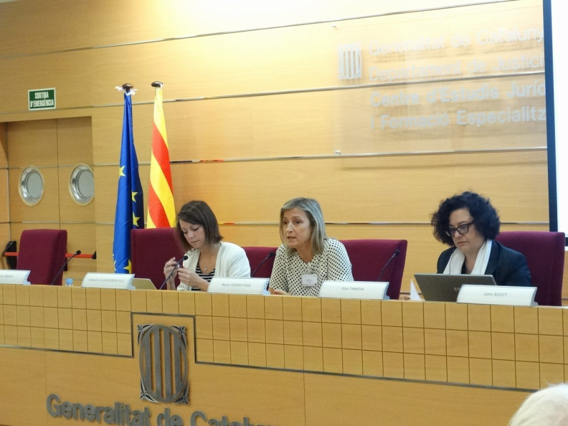
Plenary Session 1

Chair: Marta Ferrer Puig, Head of the Department of Social and Criminological Research and Training, Ministry of Justice, Catalonia
Experts: Ms Eve Entenmann, Programme Manager, International Centre for Counter Terrorism, (NL)
Ms Ilina Teneva, Secretary of the Council for Penological Cooperation (PC-CP), Council of Europe (CoE),

Ms Eva Entenmann, Programme Manager, International Centre for Counter Terrorism
What is radicalisation? It is not an easy answer. An expert recently said “when it comes to terrorism there are a lot of type of terrorism and definitions” in fact, only in the U.S., there are at least 20 different definitions of terrorism. Radicalisation is a contested concept; why do people commit acts of terrorism? At the present day, the studies on radicalisation mainly focus on radical Islam.
The element everyone agrees on is that radicalisation is a dynamic process based on three different levels: micro-level; meso-level; macro-level. It is still regarded as a complex social and sociological phenomenon that largely depends on the context.
Radicalisation is not necessarily about radicalism but about extremism: a complete disregard on the rule of law and most of all, no tolerance for other views. Radicalisation could lead to violent or non-violent extremisms. In the former case, violence is seen as a vehicle to reach an aim.
However, the radicalisation process is a more in depth and intrapersonal phenomenon: it does not necessarily lead actual violence. There are two level of thinking and it is not a linear process: it is a step model.
It is possible for individuals to self-radicalise and to become lone wolves thanks to the internet. Internet may radicalise individuals but a real approach is still necessary. From the theoretical point of view is important to understand the process that may lead to de-radicalisation and prevention of radicalisation, when we design intervention we need to look at the 3 level (to understand where it all originated from). it is said that 10% of terror groups are defeated by military force, this percentage makes it necessary to plan an adequate intervention.

Ms Ilina Teneva, Secretary of the Council for Penological Cooperation (PC-CP), Council of Europe (CoE),
Radicalisation is a new topic for the Council of Europe. It is important to see how the European Union members are responding to this threat. The work at the EU level started in February 2015 after the Charlie Hebdo events. The EU is committed in taking actions for combating violent extremisms.
First steps were made at the level of the penological council: there was a large shared concern that prisons were places where radicalisation happens. The penological council did not fully agree with this view, as it considers the prison population of radicalised individuals very small. Prisons are not the only place where radicalisation happens and as such it should be undertaken as a global challenge.
The committee has approved a timeline of intervention. Considering that there are too many definitions of radicalisation, the committee has accepted only 3 definitions of radicalisation to be part of the guidelines, although there is no unique definition of radicalisation, de-radicalisation and disengagement were taken out of the guidelines as their definitions were considered too vague.
The concept of dynamic security, which is about close contact betweenprison staff and prisoners in order to prevent recidivism, will help decrease the phenomenon. Objective of the CoE guideline on radicalisation is also to involve members of the public society to prevent radicalisation and to inform that prisons are not the only places where radicalisation happens.
The guidelines will also involve an ethical code, which leans on basic human rights, data protection and imprisonment as a last resort. Furthermore, stress should be put on prison and probation work. The guideline is structured in five parts that give a general framework on the matter of radicalisation.
There is a lot happening in the area of radicalisation. The indicators of radicalisation are not clear in some countries, therefore, not everyone is able to fully understand the situation. For more information www.coe.int/prison (for the guidelines)-
Interview by John Scott to Harald Føsker
What is it like to be both victim and a celebrity at the same time?
A: In a way I was lucky. I should not have been at work, but I went to take my flight tickets to Luxembourg and while I was in my office, the bomb went off. I became a celebrity because I was one of the person who was badly injured but managed to get out alive, I realized that being a celebrity was the best therapy I could get.
Q: You have been on TV, do people come up to you in the street?
A: It happened during the first 3 years from the attack. And even the most dangerous prisoners in the most dangerous prison told me that I had done a good job in handling the situation.
Q: What do they say?
A: They all felt angered by what happened
Q: When you see the picture of Utoya what makes you feel like?
A: It makes me feel highly uncomfortable as 69 people were executed in cold blood.
Q: The horror of a man hunting down 69 people, is it a source of anger for all Norwegians?
A: It is normal to be angry for something that cruel. I could understand a bomb, but executing 69 youngsters in cold blood is something unbelievable.
A: What was the reaction of your prime minister? What lead was taken?
A: He responded in good ways: saying that we have to beat terrorism with more democracy. He hit the heart of everyone at that time. During the court case, Breivik was cold as ice and the people were angered but there were no attacks on him.
Q: You were just collecting tickets, you should not have been in this building (shows picture of wrecked building and Harold’s office). How long did you have to wait to get help?
A: It felt like a week, I remember I was speaking on my mobile with my boss when suddenly something knocked me down. As I woke up, I was blind and could hear sirens it was horrible, but I was very calm although I had concussion, brain bleeding and many screws in my skulls.
Q: As you were waiting there, did you not feel fear?
A: No I was extraordinary calm, I was shouting for help and I realised I had lost my voice but I did not dare to move, I was frightened that someone could finish the job by shooting at me.
Q: How did the rescue arrive?
A: I was there and the police arrived I could hear them but I could not see them.
Q: How long were you in hospital?
A: No more than 8 weeks plus sitting on the dentist chair for 100 hours.
Q: How long was it before you went back to work?
A: It took 1 year, but I was partly on job after Christmas.
Q: Was part of your motivation not to be beaten by the terrorist?
A: I am an adult man and told to myself: he is not going to decide when I have to stop working.
Q: The picture behind, what is happening here?
A: the Prime minister wanted to see how we were doing and wanted to say ‘hi’ to the patients.
Q: You went back to a job, working in the prison service, where the man who changed your life was held, how did that feel?
A: I have never felt anything, as he is a no-man to me. I am glad to have seen him in court, as I felt much superior to him
Q: One of the big debate was related to the mental sanity to Breivik; did you want to define him as insane?
A: That could have been a really bad thing, if he was declared insane, he would have been transferred to a psychiatric ward and not recognized as guilty; when you have been planning an act like that for 3 years you are mentally capable
Q: Was he not mentally sick considering all the work he carried out?
A: No, although a second committee wanted to declare him mentally ill.
Q: What impact did this have on you?
A: I have lost my vision although I have been much more confident with my profession. It improved my professionality
Q: Do you sleep well? What keeps you awake?
A: No, I do not sleep, I don’t have nightmares about the terror attacks, but I still woke up tonight.
Q: The impact on you was lasting, what about Norwegian society?
A: I think it will never been forgotten, old people compare this with World War II acts. It will be a very lasting memory for all of us. Young people are not so aware about what happened, but nevertheless it should never been forgotten.
Q: Is it a reality check for Norway?
A: Yes, we knew that something would happen at some time, we also wanted to close that road where the bomb was placed in March but we didn’t.
Q: How did you feel sitting two meters away from Breivik in court?
A: I felt comfortable and superior.
Q: Your professionalism was important for your recovery?
A: Absolutely
Q: Does the prisoner have a special regime?
A: He was moved from prison to prison. He is isolated. He has changed his lawyer and is surrounded by the relevant services. He is doing political science studies. So he is isolated but not completely alone.
Q: Is it a lesson learnt for the society?
A: The principle of normality is what should guide prisons and societies. My experience as a victim has been a good one and I hope we can have policies that will take into account other types of victim.

Questions from the floor
Q: Luxembourg prison governor: You mentioned a question about insanity; when we speak about insanity, it is understood as a mental illness and finally the judges agreed that he was not insane. Most of us might think he is not normal either. The problem is that prisoners find themselves in a limbo of non-normal sanity who do not share the same values as normal people: how can we deal in the future with people who reject these values and not adhere with these?
A: Prisons nowadays are filled with people who do not share society’s core values. Two main concepts in the guidance are democracy and good prison management; if we are aware of these two concepts, we are on the good track.
Q: Switzerland: I was curious if this man was going to talk to you, would you talk to him?
A: No I wouldn’t talk to him, for me restorative justice will not ever be to meet him and understand.
Q: Could legislation change because of one crime?
A: Something has changed, we were not used to terrorism and we have to debate more on some products of society as we are talking about a self-radicalised man.

EuroPris - European Organisation of Prison and Correctional Services
EFRJ- European Forum for Restorative Justice
CEP - Confederation of European Probation

